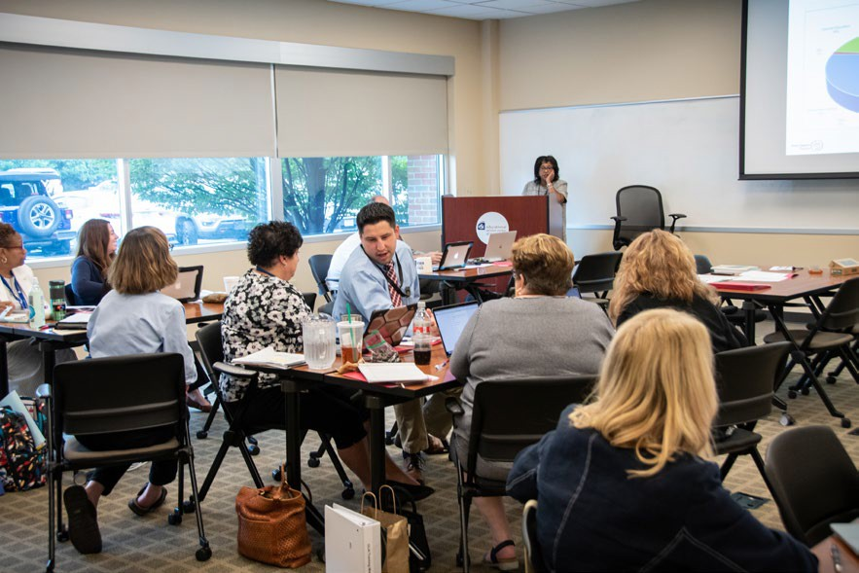
Unless noted, all SST11 professional development sessions will be held at the ESC of Central Ohio.

PD Locations
Educational Service Center of Central Ohio 2080 Citygate Dr.
Columbus, OH 43219

OCCRRA
2760 Airport Drive, Suite 160
Columbus, OH 43219

This document was supported in whole or in part by the U.S. Department of Education, Office of Special Education Programs, (Award #H173A160111, CFDA 84.173A,
awarded to the Ohio Department
of Education). The opinions expressed herein do not necessarily reflect the policy or position of the U.S. Department of Education, Office of Special Education Programs, and no official endorsement by the Department should be inferred.

Who We Are

State Support Team Region 11
2080 Citygate Dr.
Columbus, OH 43219
Phone: (614) 753-4694
www.sst11.org

Administration
Rhonda Dickson, Director 614.753.4707
Greg Mathews, Assoc.Dir 614.753.4688
Helene Stacho, Coordinator 614.753.4692

 | Consultants
Ugochi Akoi | 614.542.4162
Juakita Bowens | 614.542.4148
Kimberly Brown | 614.753.4169
Cindy Eldridge | 614.753.4689
Kimberly Fausnaugh |  | 614.753.4653
Tara Finton |  | 614.542.4126
Tia Jackson |  | 614.542.4144
Barb Knipe |  | 614.753.4687
Steven Moran |  | 614.753.4680
Eric Neal |  | 614.542.4134
Melanie Peloquin |  | 614.753.4686
Thomas Stacho |  | 614.753.4693
Terri Wendt |  | 614.542.4129
Support Staff
Sandra Beach | 614.753.4677
Leslie DeLuca | 614.753.4694
Tina Forshey | 614.753.4681
Kathy Reedy | 614.753.4690
Ann Slane | 614.753.4691

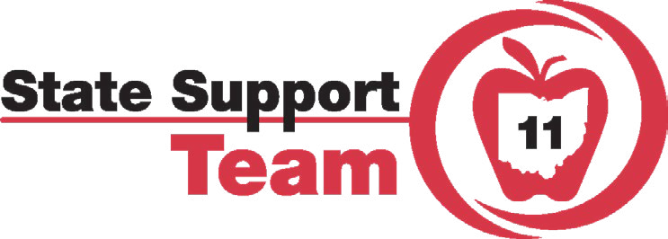

Professional Development Opportunities

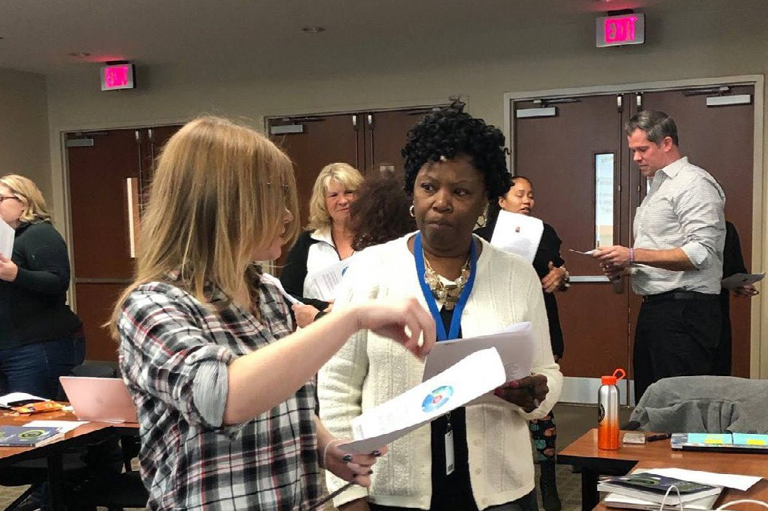

Registration:
Unless otherwise noted, register for SST11 professional development events at ohid.ohio.gov.

Preschool registration for SUTQ is available in OCCRRA at occrra.org.

For questions about registration, please contact Leslie Barrett at leslie.barrett@escco.org or call 614.753.4694.

Please check our professional development calendar online for the most up-to-date information at www.sst11.org.

In the event of inclement weather, ALL cancellations will be posted by 7:00 a.m. on sst11.org. In some cases, the workshop may be cancelled or delayed.

August-November 2020 November-April 2021 April-June 2021
11/17/20 | 9:00 a.m. -  2:00 p.m. | FAM | Surrogate Parent Training
11/18/20 | 2:00-3:30 p.m. | TR | Postsecondary Transition Community of Practice
11/20/20,  1/29/21  & 3/5/21 | 8:30 a.m. -  12:00 p.m. | EC | Creating an Inclusive Early Childhood Classroom
11/30/20,  1/11/21 &  3/15/21 | 9:00 a.m. -  3:00 p.m. | EC | Emergent Literacy
12/1/20 | 9:30-11:00 a.m. | FAM | Family Engagement
12/11/20 | 9:00-11:30 p.m. | SPED | ESELA
1/12/21 | 9:00 a.m. -  3:00 p.m. | SPED | Alternate Assessment INITIAL
1/13/21 | 10:00 a.m. -  12:00 p.m. | EC | Early Childhood Supervisor Network
1/20/21 | 9:00 a.m. -  3:00 p.m. | SPED | Alternate Assessment INITIAL
1/21/21 | 9:00 a.m. -  2:00 p.m. | FAM | Surrogate Parent Training
1/22/21 | 9:00-11:30 a.m. | SPED | ESELA
1/26/21 | 9:00 a.m. -  3:00 p.m. | SPED | Alternate Assessment INITIAL
1/29/21 | 9:00-11:30 a.m. | SI | Continuous Improvement Network
1/29/21 | 9:00-11:30 a.m. | SPED | COSEAs
2/9/21 | 9:00-10:00  a.m. | PBIS | PBIS Network
2/12/21 | 9:00-11:30 a.m. | SPED | ESELA
2/24/21 | 2:00-3:30 p.m. | TR | Postsecondary Transition Community of Practice (Virtual)
2/24/21 | 9:00 a.m. -  3:30 p.m. | PBIS | Classroom Management-Best Practices
3/4/21 | 9:00-11:30 a.m. | SI | Culturally Responsive Practices
3/12/21 | 9:00-11:30 a.m. | SPED | ESELA
3/17/21 | 10:00 a.m. -  12:00 p.m. | EC | Early Childhood Supervisor Network
4/9/21 | 9:00-11:30  a.m. | SI | Continuous Improvement Network

9/18/20 | 9:00-11:30 a.m. | SPED | ETR Train the Trainer
9/18/20 | 1:00-3:30 p.m. | SPED | IEP Train the Trainer
9/22/20 | 9:00-10:00 | PBIS | PBIS Networking
9/29/20 | 9:00 a.m. -  12:00 p.m. | TR | Postsecondary Transition Tier 2
9/30/20 | 2:00-3:30 p.m. | TR | Postsecondary Transition Community of Practice (Virtual)
10/1/20,  12/2/20 &  1/28/21 | 9:00 a.m. -  3:30 p.m. | PBIS | PBIS Tier 1 District Team Training
10/1/20 | 9:00 a.m. -  12:00 p.m. | T&L | Teacher Clarity District Leaders
10/8/20 | 10:00 a.m. -  12:00 p.m. | EC | Early Childhood Supervisor Network
10/9/20 | 9:00-11:30 a.m. | SI | Continuous Improvement Network
10/14/20 | 9:00-11:30 a.m. | SPED | ETR Train the Trainer
10/14/20 | 1:00-3:30 p.m. | SPED | IEP Train the Trainer
10/15/20,  12/9/20 &  3/4/21 | 9:00 a.m. -  3:30 p.m. | PBIS | PBIS Tier 3 Building Team Training
10/16/20 | 9:00 a.m. -  12:00 p.m. | SPED | ESELA
10/22/20 | 9:00-11:30 a.m. | SI | Culturally Responsive Practices
10/23/20 | 9:00-11:30 a.m. | SPED | COSEAs
10/27/20,  11/19/20,  3/2/21 &  6/8/21 | 9:00 a.m. -  3:00 p.m. | T&L | Teacher Clarity
11/4/20 | 9:30-10:30 a.m. | SPED | Career Tech Center  Region 11 Network | R
11/5/20 | 9:00 a.m. -  3:00 p.m. | PBIS | Classroom Management-Best Practices
11/6/20 | 9:00 a.m. -  12:00 p.m. | SPED | ESELA
11/10/20 | 9:00-10:00  a.m. | PBIS | PBIS Network
11/10/20 | 9:00-11:30 a.m. |  | Central Ohio Literacy Leaders Network

4/13/21 | 9:00 a.m. -  2:00 p.m. | FAM | Surrogate Parent Training
4/13/21 | 9:00-10:00  a.m. | PBIS | PBIS Network
4/14/21 | 2:00-3:30  p.m. | TR | Postsecondary Transition Community of Practice
4/23/21 | 9:00-11:30  a.m. | SPED | COSEAs

Key for Professional Development

EC | Early Childhood
FAM | Family & Community Partnership
PBIS | Positive Behavioral Interventions & Supports
SPED | Special Education
TR | Transition
T&L | Teaching & Learning
SI | School Improvement
Updated: 8/18/20

